Name: ___________________________________ Date: ______________________ Period: _______

# Independent Practice: Punnett Squares

Complete the table below using the information provided to the left, and then complete each of the Punnett squares and their accompanying questions.



Tt × Tt

**1. What percentage of the offspring will have a tall phenotype? __________**

**2. What percentage of the offspring will have a homozygous recessive genotype? __________**

**3. What percentage of the offspring will have long beaks? __________**

**4. What percentage of the offspring will have a heterozygous genotype? __________**

LL × Ll

**5. What percentage of the offspring will have a homozygous dominant genotype? __________**

**6. What percentage of the offspring will have white eyes (dd)? __________**

Dd × Dd

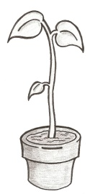

**Long beak**

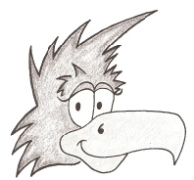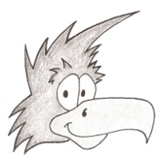

**Dark eyes**

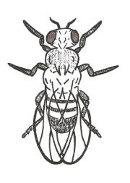

**Tall**

**Tall**

**Long beak**

**Dark eyes**



**7. What percentage of the offspring will have purple flowers as their phenotype? __________**

**8. What percentage of the offspring will have a heterozygous genotype? __________**

**White flowers**

**Purple flowers**

Pp × pp

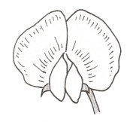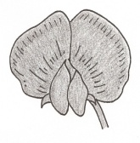

**White eyes**

**9. What percentage of the offspring will have a heterozygous genotype? __________**

**10. What percentage of the offspring will have white eyes? __________**

**Dark eyes**

Dd × dd

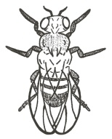

**Tall**

**Tall**

**11. What percentage of the offspring will be short? __________**

**12. What percentage of the offspring will have a tall phenotype? __________**

Tt × Tt

**13. What percentage of the offspring will have the phenotype of gray hair? __________**

**14. What percentage of the offspring will have a homozygous recessive genotype? __________**

**White fur**

**Gray fur**

GG × gg

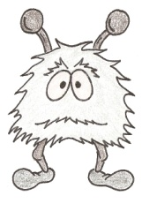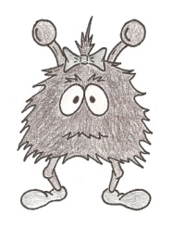

**15. What percentage of the offspring will have long beaks? __________**

**16. What percentage of the offspring will have a heterozygous genotype? __________**

**Short beak**

**Long beak**

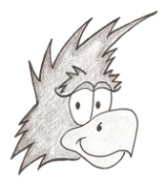

Ll × ll

© Haney Science